How to set up the Behringer BCR2000
to control the MicroKorg parameters

By Murray Lorden
www.punknewwave.com
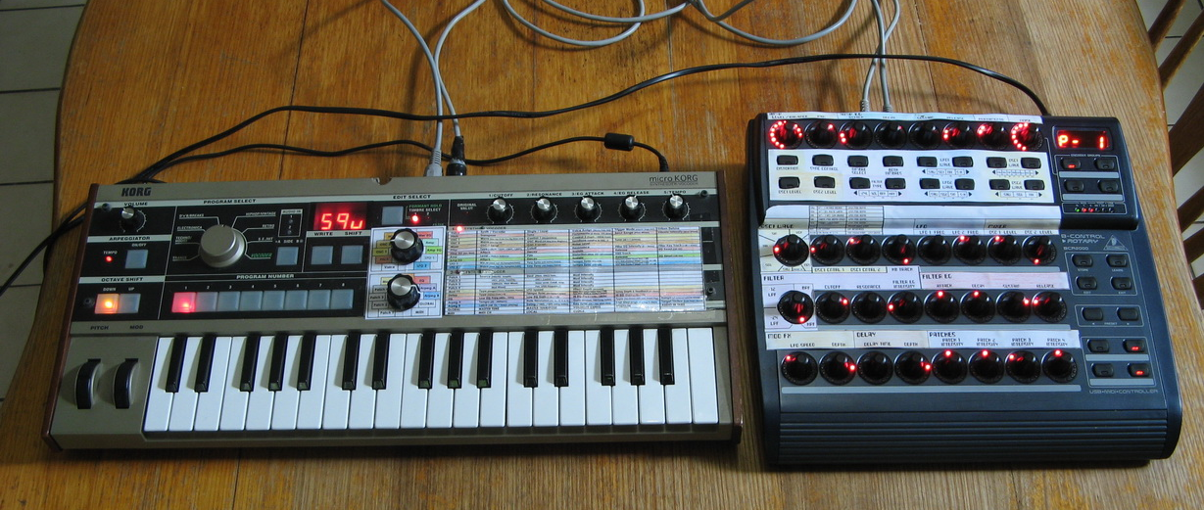

Overview
This document explains how to set up a preset on your BCR2000 that will allow you to use the knobs and buttons to control most of the parameters of the MicroKorg, all easily accessible on the one control surface.
I got frustrated that you can only tweak a few knobs at a time on the MicroKorg. So I made this, and thought others might like it too!
Once you set up and save this preset on the BCR2000, it’s good to go forever! It works for all the different sound presets on the MicroKorg.
All you need to do is follow the instructions below to program the settings into your BCR2000, and save it as a Preset.
If you already know how to program the BCR2000 knobs and buttons, and understand about MIDI CC values, you might want to just go ahead and program in the settings show below. If you want a more step by step guide, see further down in this document…

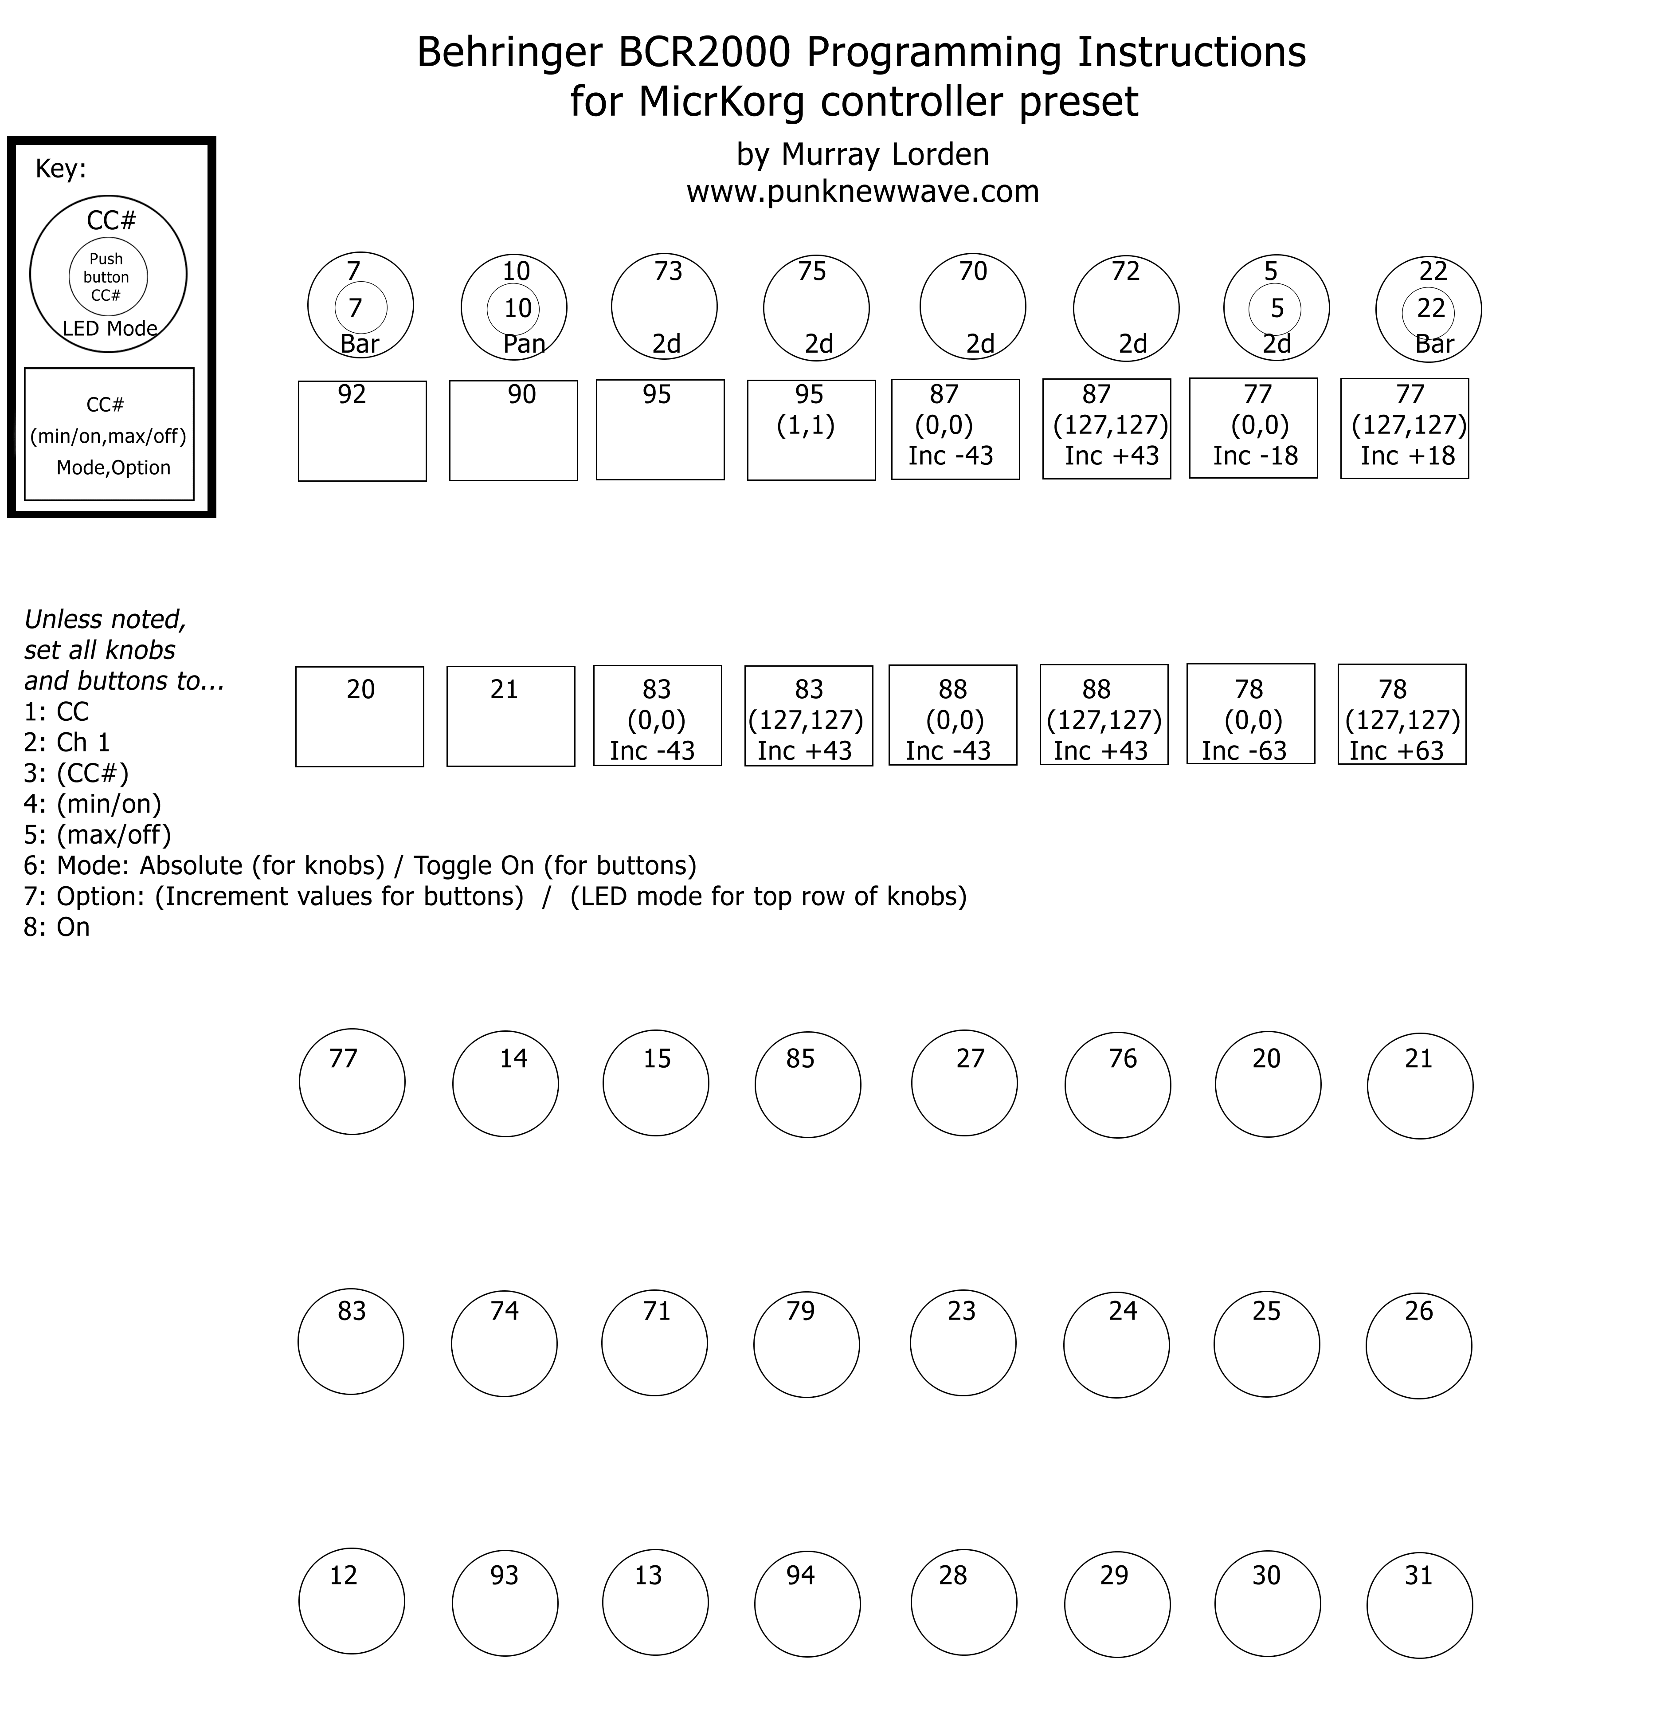

You can download a full size version of this image here…
BCR Settings Sheet

Printing out & sticking down the overlays on your BCR2000

Download the Overlay Images here…
Overlay Printout (Top)
Overlay Printout (Bottom)

Sticking the Overlays onto your BCR2000
Make sure you print the images at 100% real size, on A4 paper set to print in Landscape mode.
Cut them out as shown below. (I cut a little curved bit on the top left corner of the Bottom image, so it curved up around OSC1 Wave neatly).
Then blu-tack it onto your BCR2000.
Note: I tried sticky tape, but the BCR2000 surface is pretty much sticky tape proof! It just peels off again! So I found blu-tack worked really well, and looks much better anyway. I put small dots of blu-tack on all the corners and various other places on the overlay, and pressed it down. The more little bits you put on, the more evenly you can stick it to the BCR, so I’d recommend about 20 or more little dots of blu-tack in total. It’s important to use plenty of little dabs of blu-tack around the part that curves up from the bottom to the top section.

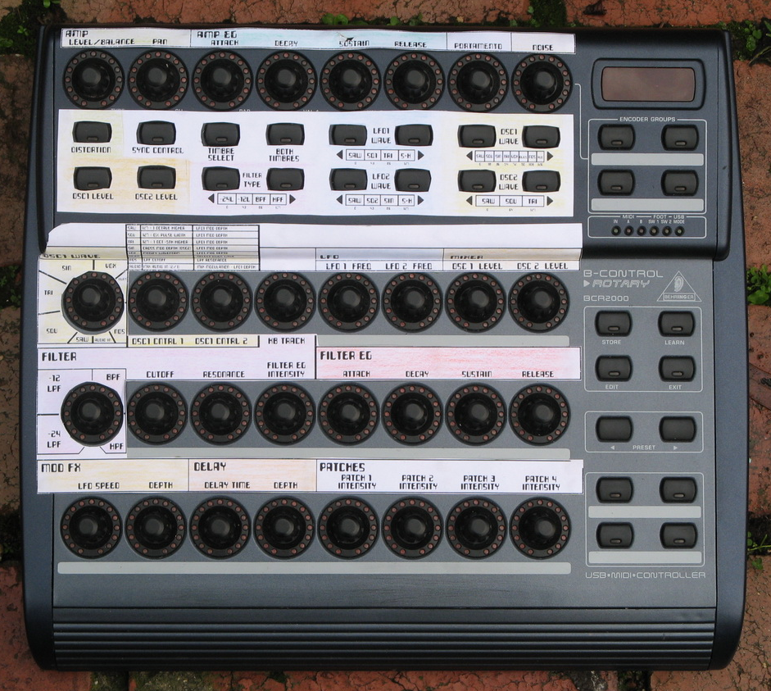

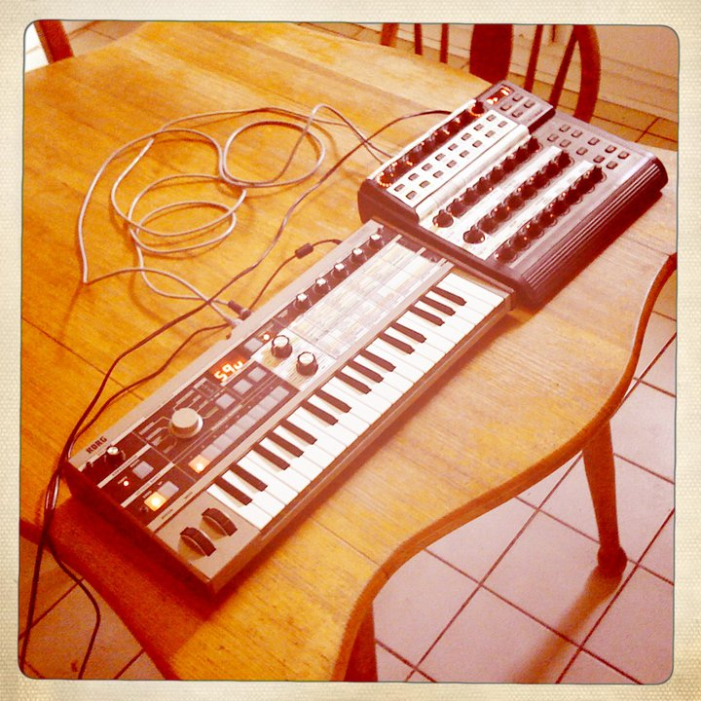
Getting set up

- Set up the two units side by side. Power them up.
- Plug a MIDI cable from the BCR2000 (MIDI out) to the MicroKorg (MIDI in).
- Plug a MIDI cable from the MicroKorg (MIDI out) to the BCR2000 (MIDI in).

Preparing the BCR2000
- Set your BCR2000 to “Stand Alone Mode S-1”. The Operating Mode sets up how the MIDI data is routed. It probably works in some of the other modes as well, but this is the one I use.
  - Hold down the EDIT button, and press STORE at the same time.
  - You are now in the Global Setup menu and you can let go of both keys.
  - Select an Operating Mode by turning the very top left knob. Turn it until you see S-1 on the readout display.
  - Set the BCR2000 MIDI Channel. I use MIDI Channel 1. Turn dial 2 (which says “CH” below it) until it’s says “1”. You’ll need to set the MicroKorg channel to the same number in a step below.
  - Press EXIT to exit the Global Setup menu.
  - Note that this mode is saved automatically, and doesn’t need to be saved. Every time you turn it on, it will be in the same Operating Mode that you left it in when you turned it off.

Preparing the MicroKorg
- Set both the MicroKorg and the Behringer BCR2000 to use the same MIDI channel. I just use Channel 1. You can use any channel you want. Just make sure both are set to the same channel.
  - We set the BCR2000 MIDI Channel to “1” above, so now we set the MicroKorg to Channel 1 as well.
  - On the MicroKorg, turn the EDIT SELECT 2 knob to “MIDI”, then rotate knob 1 to select the MIDI channel. Set it to “1”.
  - Now we have the BCR2000 and the MicroKorg sending their MIDI data on Channel 1, and so they can talk to each other!
Information about Programming the BCR2000

Now we can get down to programming the BCR2000 to send the appropriate messages to the MicroKorg to control it!
We won’t be programming the MicroKorg at all. The MicroKorg will automatically send the values back to the BCR2000 when you turn a knob on the MicroKorg. We just need to setup the BCR2000 so that each knob and button sends the right MIDI information to the MicroKorg!

MIDI CC (Control Changes)
As a quick explanation of what we’ll be doing, we just want the BCR2000 to send MIDI CC (Control Change) information to the MicroKorg. The MicroKorg has a specific set of CC#s assigned to it’s parameters, and these can be controlled by an external controller. (These are listed below for your interest in the Reference Section at the bottom of this document. They can also be found on page 56 of the MicroKorg manual along with further MIDI information).
Not ALL parameters are accessible via the CC#s, but most are. Not ALL of the available CC#s even fit onto the knobs and buttons BCR2000 interface, so I’ve chosen 5 or 6 parameters to leave off. You could adjust these to suit yourself, but I think the custom overlay I’ve created for the BCR2000 works well. (I’ve left off the settings for OSC2, as you can use the MicroKorg interface itself to adjust these parameters well).
The BCR2000 has 32 slots for presets which can be cycled through using the Preset button on the right hand side. The end result we will achieve here is a single preset (I use Preset slot 1), that controls the MicroKorg. You just switch on both units, plug them in with the MIDI cables, and it’s all set up and ready to go! The same controls apply to all MicroKorg programs. They are just a generic set of controls to adjust the LFO speeds, OSC waveforms, Delay Depth, Filter Cutoff, etc, etc…
The main information you’ll need about editing the BCR2000’s knobs and buttons can be found on pages 14 and 15 of the BCR2000 manual. I’ve included the information relevant to setting CC settings below in the Reference Section at the bottom of this document.

Setting the CC values on the BCR2000
For each knob and button you will set the values using the process below…
Hold down the EDIT button, and turn the Knobs or push the Button that you want to edit.
Then let go of the EDIT button, and you’re ready to edit the parameters for that knob or button.
Use the top row of knobs on the BCR2000 to set the various values according to the BCR Settings Sheet (link at top). Refer to the BCR Editing tables below for the available options.

Knob 1: Always set this to CC (to tell it to send MIDI “Control Change” information).
Knob 2: Always set this to MIDI Ch 1.
Knob 3: Set the appropriate CC# here, according to the BCR2000 Settings Sheet.
Knob 4: Where applicable, set the (Min/On) value here, according to the BCR Settings Sheet.
Knob 5: Where applicable, set the (Max/Off) value here, according to the BCR Settings Sheet.
Knob 6: Set to Absolute for Knobs, and Toggle On for Buttons.
Knob 7: This can set the LED mode for the top row of encoders only.
Knob 8: Always set to On. This sets whether the control should show it’s value in the display.

Then press EXIT when you’ve finished with that knob or button, and move to the next knob or button!

Remember to save your preset when you’ve finished, before you turn the unit off! I save often, in case the power gets bumped out or something. To save, you just press STORE once, then use the Preset < > arrows to select which Preset number to save over, then press STORE again. Mostly this just involves pressing STORE, then STORE again.

And you’re done!

Help wanted! Let me know if you can make this work even better!
The thing I CAN’T figure out is how to get the MicroKorg to send all the CC# values over to the MicroKorg each time you switch to a new MicroKorg program.
- So if you select a new MicroKorg preset sound, the BCR2000 remains on all the old values, and no longer represents what’s going on on the MicroKorg, until you move a knob and overwrite the CC# value.
- It still works fine, but it would be ideal if the MicroKorg sent a Data Dump for the current program over to the BCR2000.
- My plan was to set one button on the BCR2000 to Request a Data Dump from the MicroKorg for 1PROG of data. But I just can’t get this to work, despite following the instruction in the manuals for each device.
- If someone could help me to work out how to do this, that would be fantastic!!!

Reference Section

BCR Editing: Encoders (Knobs)

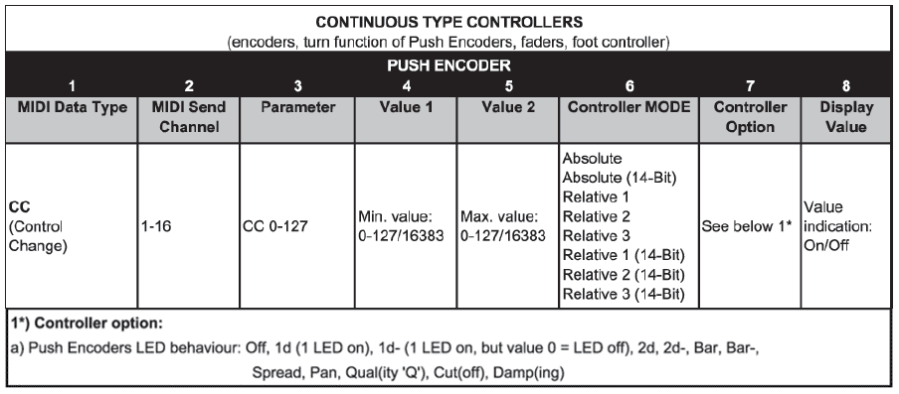

Note that the Push Encoder LED behaviours mentioned at the bottom only apply to the very top row of knobs, which have support for these more complex LED settings, and are also push buttons.

BCR Editing: Buttons

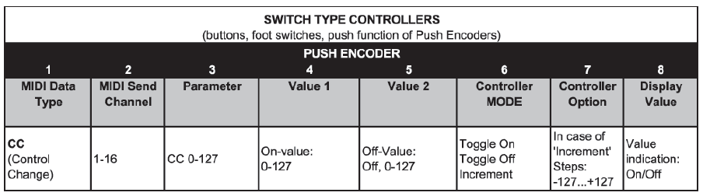

MicroKorg: MIDI CC#s

